**Project Report Format**

# INTRODUCTION

1.1 Project Overview:

LearnHub is a modern, minimalist digital learning platform designed to streamline the process of online education. It allows students to browse and enroll in courses, track their progress, and receive completion certificates. Teachers and administrators are equipped with tools to manage users and courses via a responsive admin dashboard.

1.2 Purpose:

The purpose of LearnHub is to provide a centralized, efficient, and user-friendly platform for digital learning. It focuses on accessibility, role-based management, and effective delivery of educational content to bridge the gap in digital education.

# IDEATION PHASE

2.1 Problem Statement:

Students often struggle with fragmented learning systems that lack consistency, accessibility, and tracking capabilities. Similarly, teachers and admins face difficulty managing courses and user data effectively across platforms.

2.2 Empathy Map Canvas:

**Users**: Students, teachers, and admins

**Says**: "I want to learn/manage easily", "I need access to resources and certification."

**Thinks**: “Will this platform help me achieve my goals efficiently?”

**Does**: Browses courses, uploads materials, monitors progress **Feels**: Overwhelmed by poor UI/UX, frustrated by lack of tools

2.3 Brainstorming:

User role management

Course video uploads

Certificate generation

Admin dashboard

Mobile responsiveness

Progress tracking system

# REQUIREMENT ANALYSIS

3.1 Customer Journey map:

Visit the website

Register/Login

Browse courses

Enroll and start learning

Track progress Complete course

3.2 Solution Requirement:

Authentication system ( JWT-based )

Video hosting & streaming

Certificate generation

Course management tools

Frontend with responsive UI

3.3 Data Flow Diagram:

3.4 Technology Stack:

Frontend: React (Vite, MUI), React Context

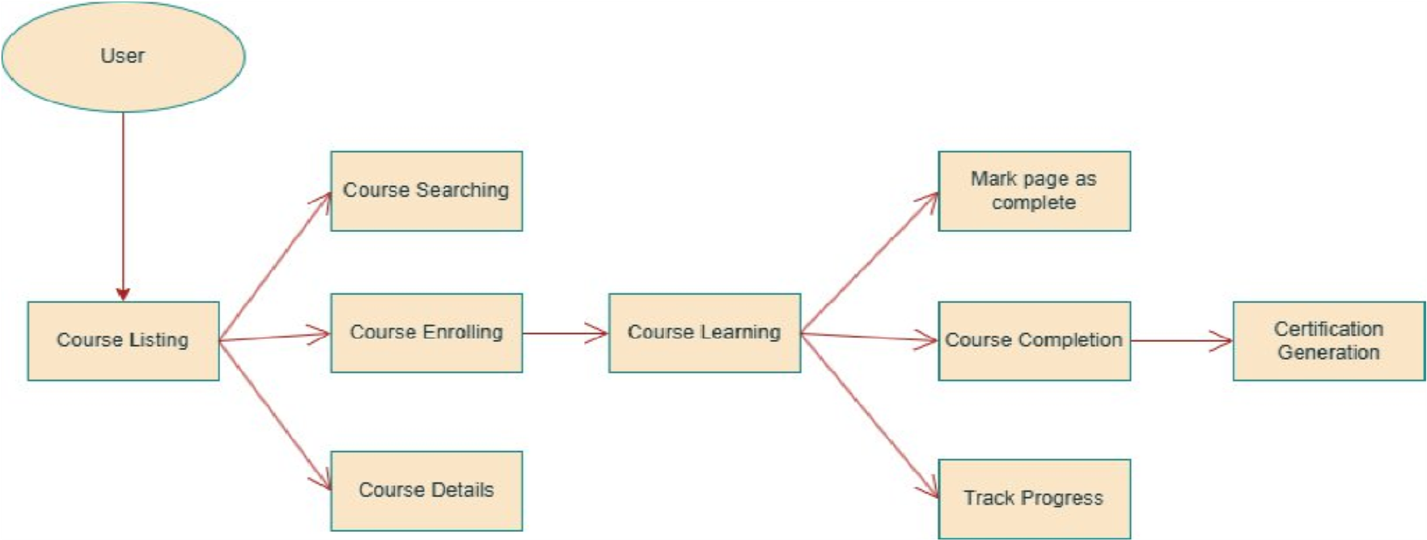

Backend: Node.js, Express.js, JWT, Multer

Database: MongoDB ( Mongoose )

Dev Tools: Git, npm, Postman

# PROJECT DESIGN

4.1 Problem Solution Fit:

A unified learning system like LearnHub simplifies the educational process for all stakeholders. It eliminates the need for third-party tools and consolidates features in one ecosystem.

4.2 Proposed Solution:

Develop a full-stack MERN web application where users can interact based on roles:

Students: Enroll, view courses, download certificates

Teachers: Upload courses, manage content Admins: Manage users, approve content

4.3 Solution Architecture:

Frontend: React ( SPA )

Backend: RESTful APIs

Database: MongoDB with Mongoose schemas

Auth: JWT with role-based access

# PROJECT PLANNING & SCHEDULING

5.1 Project Planning:

Requirements Gathering

UI/UX Prototyping

Backend API Development

Frontend Integration

Testing & Debugging

Deployment & Demo

# FUNCTIONAL AND PERFORMANCE TESTING

6.1 Performance Testing:

Basic load testing using Postman collections and developer tools.

JWT authentication tested for expiry, storage, and secure routing. File upload performance tested via Multer middleware.

# RESULTS

# Output Screenshots:

**Landing**

**Page:**

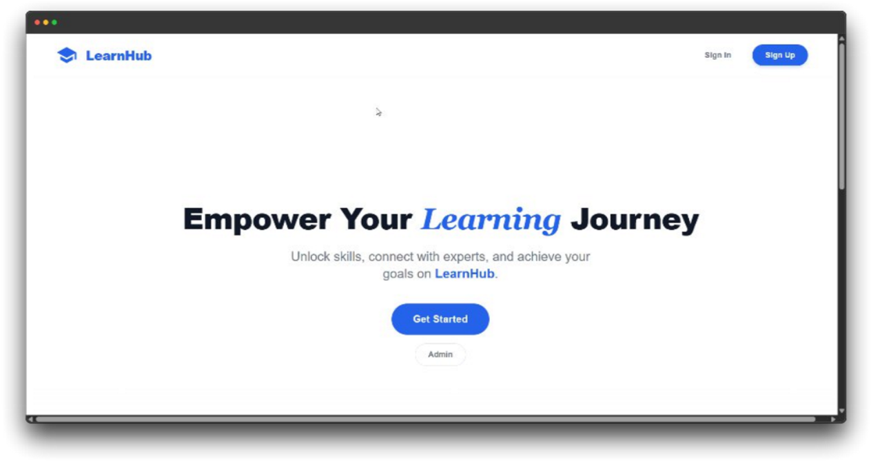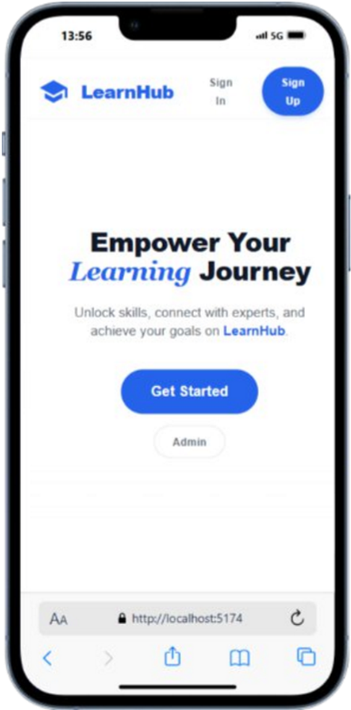

# Registration Form:

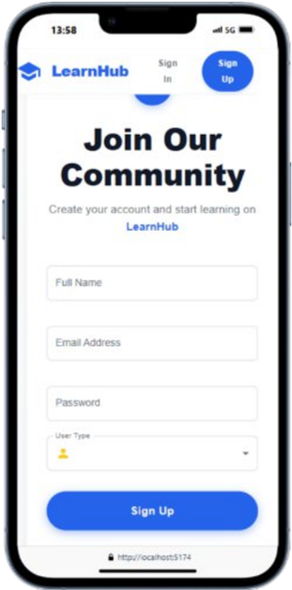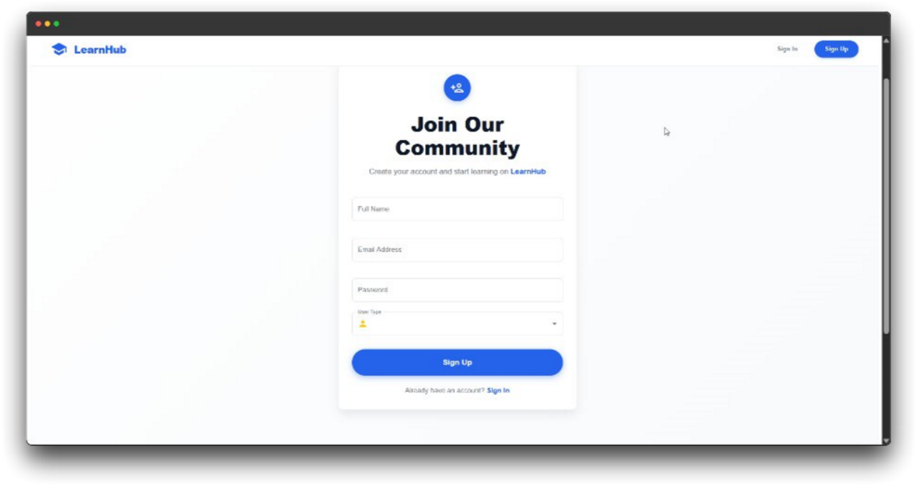

**Login**

**From:**

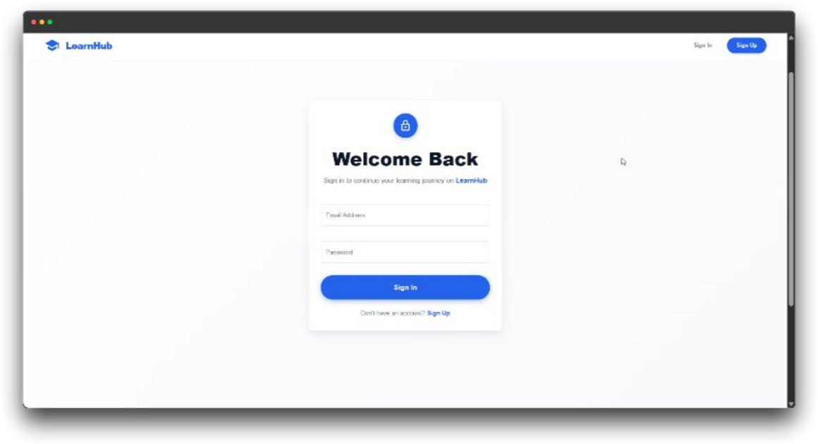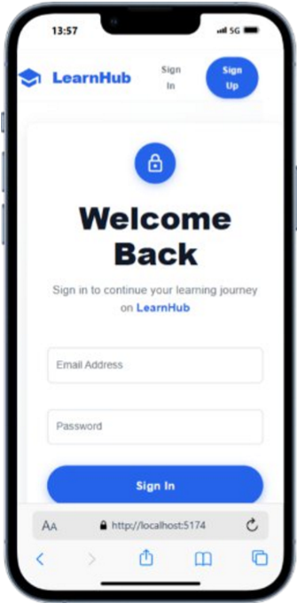

# ADVANTAGES & DISADVANTAGES

# Advantages:

Role-based access

Certificate generation

Responsive interface Scalable architecture

# Disadvantages:

No real payment integration (demo only)

Minor UI inconsistencies on small devices

Certificate formatting issues on some browsers

# CONCLUSION

LearnHub successfully demonstrates how a modern, accessible, and role-based online education system can empower both learners and educators. With core functionalities in place, it lays a strong foundation for further enhancements and real-world deployment.

# FUTURE SCOPE

Integrate real payment gateway (e.g., Stripe, Razorpay)

Push notifications and messagingCertificate Generation

Certificate Generation

Upload additional content types (PDFs, Quizzes)

Enhanced accessibility & automated testing

# APPENDIX

Source Code :

https://github.com/mounikapasupuleti2004/Learnhub

Dataset Link: N/A

GitHub & Project Demo Link : DEMO LINK : LEARNHUB